A PROJECT REPORT ON

## Facial Recognition Enabled Attendance Record System

Submitted in partial fulfilment for the award of the degree of Bachelor of Technology in

**Computer Science Engineering**

(Rajasthan Technical University, Kota)



### SESSION (2022-2023)

SUBMITTED TO:

**Dr. C. P. Gupta**

**(Professor)**

SUBMITTED BY:

**Sonu Kumar (19/530)**

**Sparsh Jain (19/531)**

SUPERVISOR:

**Ms. Gowri Choudhary**

**(Asst. Professor)**

**DEPARTMENT OF COMPUTER SCIENCE AND ENGINEERING**

**UNIVERSITY DEPARTMENT,**

### RAJASTHAN TECHNICAL UNIVERSITY, KOTA-324010

**DECLARATION**

We hereby declare that the work, which is being presented in the project report, entitled “Facial Recognition Enabled Attendance Record System”, in partial fulfillment for the award of the Degree of “Bachelor of Technology” with Specialization in Computer Science and submitted to the Department of Computer Science and Engineering, Rajasthan Technical University Kota, is a record of our own investigations carried under the guidance of Ms. Gowri Choudhary, Assistant Professor, Department of Computer Science and Engineering, Rajasthan Technical University Kota.

We have not submitted the matter presented in this report anywhere for the award of any other Degree.

(Name and Signature of Candidate)

**Sonu Kumar (19EUCCS060)**

**Sparsh Jain (19EUCCS061)**

Computer Science and Engineering

Rajasthan Technical University, Kota

Counter Signed by:

**Ms. Gowri Choudhary**

**(Assistant Professor)**

Department of Computer Science and Engineering

Rajasthan Technical University, Kota

Date:

**ACKNOWLEDGMENT**

This is an opportunity to express our heartfelt words to the people who were part of this final year project in numerous ways, people who gave me unending support right from the tbeginning of the Project.

We want to give sincere thanks to the Supervisor **Ms. Gowri Choudhary** for her valuable support.

We extend our thanks to **Prof. Harish Sharma**, Head of the Department for his Constant support.

We express our deep sense of gratitude to **Prof. Dr. C.P. Gupta** for continuous cooperation encouragement and esteemed guidance.

### RAJASTHAN TECHNICAL UNIVERSITY, KOTA



**CERTIFICATE**

This is to certify that the Project Report entitled “**Facial Recognition Enabled Attendance Record System**” has been submitted by **Sonu Kumar** and **Sparsh Jain** in partial fulfillment of the requirement of the degree of B.Tech in Computer Science Engineering for the academic Session 2022– 2023.

They have undergone the requisite work at Rajasthan Technical University, Kota, Rajasthan (RTU) prescribed.

**Ms. Gowri Choudhary**

**Asst. Professor**

Department of CSE

Place:-

Date:-

# Abstract

The advent of facial recognition technology has revolutionized numerous industries, and its applications continue to expand across various domains. In the realm of attendance management, the traditional methods of manual registration and time-consuming roll-call processes are being replaced by more efficient and accurate systems. This abstract presents an overview of a facial recognition-enabled attendance record system designed to streamline the attendance tracking process in educational institutions, corporate organizations, and other similar environments.

The proposed system utilizes facial recognition algorithms to identify individuals based on their unique facial features. Through the integration of high-resolution cameras and sophisticated software, the system captures and analyzes facial images in real-time, ensuring a secure and reliable means of attendance recording. The system's key objective is to automate the attendance process, eliminating the need for manual intervention while significantly reducing errors and discrepancies.

By employing machine learning techniques, the system learns and adapts to variations in facial appearances, lighting conditions, ensuring accurate recognition results. The system also incorporates robust security measures to protect the privacy and integrity of individual attendance records, adhering to applicable data protection regulations and guidelines.

Upon successful recognition, the system records the attendance information in a centralized database, which can be accessed and monitored by authorized personnel. Attendance records can be conveniently retrieved, generating comprehensive reports and analytics for administrative purposes. Moreover, the system offers real-time attendance tracking.

The facial recognition-enabled attendance record system offers several advantages over traditional attendance management approaches. It eliminates the need for physical badges or cards. Additionally, it reduces administrative burdens, allowing institutions to allocate resources more efficiently and focus on core activities.

# TABLE OF CONTENTS

|  |  |
| --- | --- |
| **Title** | **Page No** |
| Declaration | i |
| Acknowledgement | ii |
| Certificate | iii |
| Abstract | iv |
| Table of Contents | v |
| **Chapter - 1 Introduction** | **8-12** |
| 1.1 Motivation | 9 |
| 1.2 Facial Features to Create a Unique Numerical Representation | 10 |
| 1.3 Face Recognition Over Other Biometric | 10 |
| 1.4 Aim and Objective | 10 |
| 1.5 Scope of the Problem  1.6 Challenges | 11  11 |
| **Chapter - 2 Literature Review** | **13-16** |
| * 1. Research Summary | 15 |
| **Chapter - 3 Algorithm** | **17-22** |
| **Chapter - 4 Methodology and Design** | **23-29** |
| 4.1 Methodology | 23 |
| 4.2 Image Acquisition and Pre-processing procedures | 24 |
| 4.3 Flow Chart of The Image Acquisition Process | 25 |
| 4.4 Project Workflow | 26 |
| 4.5 Result | 27 |

|  |  |
| --- | --- |
| **Conclusion** | **30** |
| **References** | **31** |

**LIST OF FIGURES**

|  |  |  |
| --- | --- | --- |
| **Figures** | **Title** | **Page No.** |
| 1.1 | Facial Feature Extraction | 10 |
| 3.1 | Types of Haar Features | 17 |
| 3.2 | Haar-like Feature Selection | 18 |
| 3.3 | Applying the LBP Operation | 19 |
| 3.4 | Circular LBP | 20 |
| 3.5 | Extracting the Histogram | 21 |
| 4.1 | Method of Image Taking | 23 |
| 4.2 | Image Acquisition | 24 |
| 4.3 | Flow Chart of Image Acquisition Process | 25 |
| 4.4 | Project Workflow | 26 |
| 4.5 | Image Taking by System | 27 |
| 4.6 | Database Creation | 28 |
| 4.7 | Student Attendance | 29 |
|  |  |  |

# Chapter 1 Introduction

The management of attendance records is a crucial aspect of any organization, be it educational institutions, corporate offices, or other similar entities. Traditional methods of attendance tracking, such as manual registration and cumbersome roll-call processes, are not only time-consuming but also prone to errors and manipulation. In recent years, facial recognition technology has emerged as a game-changer in the field of attendance management, offering a more efficient, accurate, and secure solution.

Facial recognition technology utilizes algorithms to identify individuals based on their unique facial features. It captures facial images in real-time, analyzes them, and matches them against pre-registered faces in a database. The technology has witnessed significant advancements, thanks to the progress in machine learning and computer vision, resulting in more robust and reliable systems.

The aim of this final year project is to develop a facial recognition-enabled attendance record system that automates and simplifies the attendance tracking process. By leveraging the power of facial recognition algorithms, the system aims to provide an accurate, efficient, and user-friendly solution for recording and monitoring attendance.

The proposed system will consist of cameras capable of capturing facial images of individuals. These images will then be processed using LBPH facial recognition algorithm, which will analyze and compare the captured images with the existing database of registered faces. Upon successful recognition, the system will record the attendance information in a centralized database, ensuring secure storage and easy access for authorized personnel.

The project will also focus on incorporating machine learning techniques to improve the system's recognition. Privacy and security will be key considerations throughout the project, ensuring compliance with relevant data protection regulations and guidelines.

The developed facial recognition-enabled attendance record system has the potential to revolutionize the way attendance management is carried out in various sectors. It eliminates the need for physical identification cards or badges. The system also streamlines administrative tasks, freeing up valuable time and resources that can be redirected towards more productive activities.

## Motivation

The motivation behind developing a facial recognition-enabled attendance record system for this final year project stems from several key factors. The traditional methods of attendance tracking, such as manual registration and roll-call processes, have proven to be time-consuming, error-prone, and susceptible to manipulation. These outdated methods often result in inaccurate attendance records, leading to administrative challenges and a lack of accountability.

Facial recognition technology offers a compelling solution to address these shortcomings. It leverages the unique facial features of individuals to accurately identify and record their attendance. This technology has demonstrated significant advancements in recent years, showcasing high recognition accuracy rates and improved reliability. By implementing a facial recognition-enabled attendance record system, organizations can benefit from streamlined attendance management processes, enhanced accuracy, and reduced administrative burden.

Furthermore, the growing need for secure and efficient attendance management has become increasingly critical in various sectors, including educational institutions and corporate organizations. The ability to accurately track and monitor attendance not only ensures compliance with regulatory requirements but also plays a vital role in resource allocation, productivity assessment, and security measures. A facial recognition-enabled system offers enhanced security by mitigating the risks associated with unauthorized access.

Additionally, this project provides an opportunity to explore and understand the underlying technologies and algorithms employed in facial recognition systems. It allows for practical implementation of machine learning and computer vision techniques, enabling students to gain hands-on experience in developing cutting-edge technologies and expanding their knowledge in these emerging fields.

The potential impact of this final year project extends beyond the academic realm. By successfully developing a facial recognition-enabled attendance record system, students can contribute to the advancement of attendance management practices in real-world scenarios. The project's outcomes can be applied in diverse settings, ranging from educational institutions to corporate offices, fostering efficiency, accuracy, and accountability.

## Facial Features to Create a Unique Numerical Representation

## Distance between the eyes

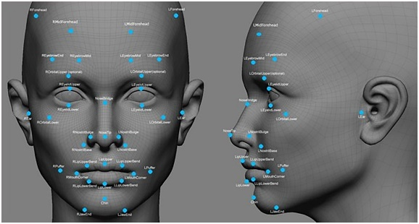

**Fig. 1.1** Facial Feature Extraction

## Shape and size of the nose

## Width of the mouth and lips

## Distance between the corners of the mouth

## Shape and size of the jawline

## Shape and size of the eyebrows

## Distance between the eyebrows

## Texture and color of the skin in various regions of the face

## Contours of the cheeks and other facial regions

## 1.3 Face Recognition Over Other Biometric

## It requires no physical interaction on behalf of the user.

## It is accurate and allows for high enrolment and verification rates.

## It does not require an expert to interpret the comparison result.

## It can use the existing hardware infrastructure, camera and image already captured without causing any problem to the device.

## It is the only biometric that allows passive identification in any environment (e.g. Identifying a terrorist in a busy Airport).

## 1.4 Aim and Objective

**Aim**

To implement a Facial Recognition Enabled Attendance Record System by considering face detection and attendance marking.

**Objectives**

**1. Develop a facial recognition system:** Design and implement a facial recognition system that can accurately identify individuals based on their unique facial features.

**2. Real-time attendance recording:** Enable real-time attendance recording by integrating cameras with the facial recognition system.

**3. Centralized attendance database:** The system should store attendance information in a structured and accessible manner, allowing authorized personnel to retrieve and monitor attendance data conveniently.

**4. Privacy and security:** Incorporate robust privacy and security measures to protect the integrity and confidentiality of attendance records.

**5. User-friendly interface:** Design a user-friendly interface for both administrators and users.

## Scope of the Problem

The scope of the facial recognition-enabled attendance record system for the final year project encompasses various aspects of attendance management and the application of facial recognition technology. The problem to be addressed and the scope of the project can be outlined as follows:

**1. Attendance Management:** The project focuses on developing a solution to streamline attendance management processes. It includes capturing attendance data, recording it in a centralized database, and providing features for administrators to monitor and analyze attendance records.

**2. Facial Recognition Technology:** The project leverages facial recognition technology to identify individuals based on their unique facial features. The scope involves implementing LBPH facial recognition algorithm, exploring machine learning techniques.

**3. Real-time Attendance Tracking:** The system aims to enable real-time attendance tracking by integrating cameras and processing algorithm. This allows for immediate identification and recording of attendance, reducing delays, and providing timely updates.

**4. Privacy and Security**: The project considers privacy and security as critical aspects. The scope includes implementing measures to protect the integrity and confidentiality of attendance records, and ensuring that the system mitigates the risks of identity theft and unauthorized access.

**5. User Interface:** The scope includes designing a user-friendly interface for administrators and users. The system should have an intuitive interface that allows administrators to efficiently manage attendance records and users to interact seamlessly with the system for attendance purposes.

## Challenges

The development and implementation of a facial recognition-enabled attendance record system for the final year project may encounter several challenges. These challenges should be considered and addressed throughout the project. Some common challenges include:

1. **Recognition Accuracy:** Achieving high recognition accuracy poses a significant challenge due to variations in lighting conditions, facial expressions, angles, and other environmental factors.
2. **Dataset Size and Quality:** Building a reliable facial recognition system requires a large and diverse dataset of facial images. Collecting and curating a comprehensive dataset that encompasses various demographics, facial appearances, and orientations can be challenging.
3. **Hardware Requirements:** Implementing a facial recognition system requires appropriate hardware, including high-resolution cameras capable of capturing clear facial images.
4. **Processing Speed and Efficiency:** Real-time attendance tracking demands efficient processing and recognition algorithms to handle a large number of facial images swiftly.

**5. System Maintenance and Updates:** Once deployed, the system requires ongoing maintenance, updates, and monitoring to address potential issues, adapt to changing requirements, and incorporate advancements in facial recognition technology. Ensuring system longevity and scalability pose additional challenges.

# Chapter 2 Literature Review

Ekta Chhatar et al[1] in this paper, the system deals with the maintenance of the student’s attendance. It generates the attendance of the student on the basis of presence and absence in class. The staff will be provided with a separate username & password.

Jun Lio[2] in this paper, a novel framework for attendance management is proposed, which consists of a mobile device and a web application. They have adopted the combination of a mobile device and web services. Registration of students is passed around among participants, one by one. Users can select one from two options, registration by selfie or registration by signature. After the registration, the ID and name which have been already registered are removed from the list of participants. An application running on the mobile device is implemented as a Monaca application.

Karwan Jacksi et al [3] in this paper, the system is designed in a way that can differentiate the hours of theoretical and practical lessons since the rate of them is different for calculating the percentages of the student‟s absence.

Jalendu Dhamija et al [4] in their paper “An Advancement towards Efficient Face Recognition using Live video feed” proposed three algorithms namely Fisherface, Principle Component Analysis (PCA), and Single Vector Decomposition (SVD) where the face recognition rate is improved by combining them. The recognition rate is improvised by the process of leaving one out a methodology and holding out methodologies

With the uptrend of machine learning and artificial intelligence gathering, IoT has procured vast heed in the totality of technology growth.

In this paper let’s crack the deformity that was proposed by other authors on face recognition algorithms.

Below are some top picks of reviewed papers:

• Shireesha Chintalapati and M.V. Raghunadh [5] presented an instinctive system, built on face recognition algorithms which says, when a student enters the classroom, his image is captured by the camera at the arrival. Only the face region is considered and then extracted for a further cook-up. Finally, after flashing onto the student’s face, it is then fed to postprocessing. Out of many methods they have chosen the Viola-Jones detection algorithm considering its high detection rate. The histogram Normalization technique has also been said to be implemented to obtain a clear image. As PCA does not consider the discriminative information in the data, Linear Discriminant Analysis (LDA) was proposed, which maximizes the ratio of the scattering. To extricate the accuracy of the system from switching database sizes, Latterly

Local Binary Pattern Histogram (LBPH) was introduced. To prevail over mockery eye blink detector is included, which holds precision regardless of the facial changes.

The main disadvantage is, that only two persons are allowed to enter the classroom at a time, to expedite the algorithm's effort and avert the cluttering of data. However, this technique

proved to be time-saving and secure, if a person poses any unintentional changes the recognition rate will gradually low down. This system can only concede a person's face up to 30 degrees angle variations, which is a drawback. This proposed system lacks accuracy.

• Suman Kumar Jha et. al.,[6] Aditya Tyagi, Kundan Kumar, and Madhvi Sharma proposed a different technique with the LBPH algorithm and Haar Cascade Classifier. LBPH is used to concede the front face and to obtain a complete attendance system. It cuts the depiction into pixels, each pixel is held by eight nearest pixels. To gain a high degree of accuracy Haar Cascade Classifier was implemented. Coming to the function, this application promotes two different parts: The development of the Face Recognition System, and the Development of the Attendance System. The first two fields hold the roll number and name of the student then the image is captured, converted to greyscale, and subsequently stored in the database.

The disadvantage of this system is the requisition of high processing power, and reduced accuracy/quality of the image as some images pose noise. It also restricts the number of students successively.

• Dulyawit Prangchumpol [7] proposed Framework of Attendance Management System to increase the correction on a conceding system, it holds five divisions first comes student registration, here face image is captured more than 10times with different expressions in vertical form. Next for face diagnosis, the author opted for the Haar cascade technique, to achieve a high degree of accuracy and speedy evaluation. Further, a program was developed for getting face results, which employs a database to compare the face of the tester to data in the system. Next comes Storage talk, here they have employed google cloud for the database, to enable editing.

Coming to the province, they deployed an android face recognition technique also called deep learning for detection purposes. Linear discriminant analysis (LDA) was included to get Fisher space, identification is done by projecting a new face onto the fisher space, then the KN algorithm is applied for identification. Euclidean distance (ED) was included for morphometric measures. After storing images of the students registered, the classifier will be trained then it will be used in the system for some courses.

All face recognition technology comes to the market with both pros and cons. Compared to another system, this technique might increase the accuracy rate gradually as the technique is associated with deep learning. This also leads to low reliability.

## Research Summary

The literature review comprises four papers focused on student attendance management systems and face recognition algorithms.

The first paper by Ekta Chhatar et al. (2016) discusses a student attendance management system that generates attendance based on the presence or absence of students in class. The system provides separate usernames and passwords for staff members.

The second paper by Jun Lio (2016) proposes a framework for attendance management using a combination of a mobile device and a web application. The system allows registration of students through options like selfies or signatures and implements a Monaca application on the mobile device.

The third paper by Karwan Jacksi et al. (2018) presents a student attendance management system that differentiates between theoretical and practical lessons to calculate attendance percentages accurately.

The fourth paper by Jalendu Dhamija et al. discusses advancements in face recognition algorithms using live video feed. They propose combining three algorithms (Fisherface, PCA, and SVD) to improve face recognition rates.

The literature review then highlights three reviewed papers on face recognition algorithms:

1. Shireesha Chintalapati and M.V. Raghunadh present a system based on face recognition algorithms. They use the Viola-Jones detection algorithm, histogram normalization technique, and Linear Discriminant Analysis (LDA). The system includes a mockery eye blink detector but has limitations regarding the number of people allowed in the classroom and face angle variations.

2. Suman Kumar Jha et al. propose a system using the LBPH algorithm and Haar Cascade Classifier for face recognition. They develop a Face Recognition System and Attendance System, but the system requires high processing power and may have reduced image quality due to noise. It also restricts the number of students successively.

3. Dulyawit Prangchumpol presents a Framework of Attendance Management System with a focus on face recognition. The system employs the Haar cascade technique, deep learning for detection, and includes features like Fisher space, KNN algorithm, and Euclidean distance. The system shows potential for increased accuracy but may have low reliability

# Chapter - 3 Algorithm

F**ace Detection** is the act of **finding** and **extracting** a face from any given image, video, webcam… based on some specific features (skin color, nose, eyes, mouth…)

This method uses the [**signs of Haar**](https://en.wikipedia.org/wiki/Haar-like_feature)— a set of elementary combinations of dark and bright areas. As shown in the figure below, signs are divided into three types: **edge**, **linear,** and **central** features.

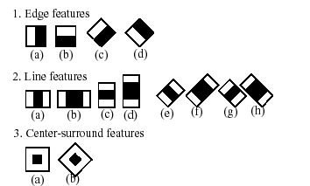

**Fig. 3.1** Types of Haar Features

So if the area in which it is found in the image, if there are enough signs, then the object can be considered found.

Each **feature** is calculated by **subtracting** the sum of pixels under the **white rectangle** from the sum of pixels under the **black rectangle**.

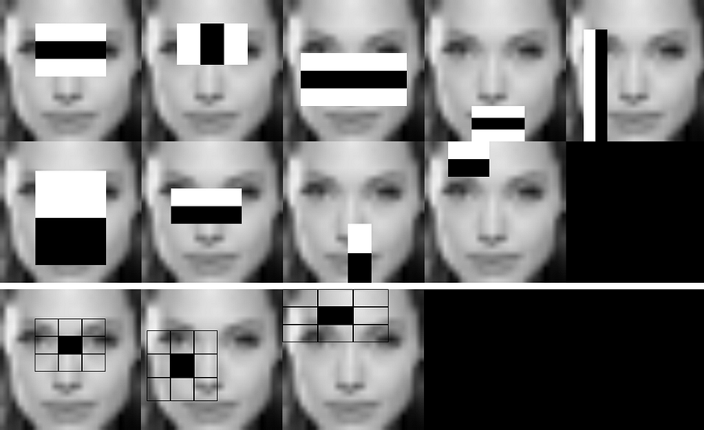

**Fig. 3.2** Haar-like Features Selection

***Local Binary Pattern****(LBP) is a simple yet very efficient texture operator which labels the pixels of an image by thresholding the neighbourhood of each pixel and considers the result as a binary number.*

It was first described in 1994 (LBP) and has since been found to be a powerful feature for texture classification. It has further been determined that when LBP is combined with histograms of oriented gradients (HOG) descriptor, it improves the detection performance considerably on some datasets.

Using the LBP combined with histograms we can represent the face images with a simple data vector.

As LBP is a visual descriptor it can also be used for face recognition tasks, as can be seen in the following step-by-step explanation.

Now that we know a little more about face recognition and the LBPH let us see what parameters are used in LBPH algorithm.

**Parameters**: the LBPH uses 4 parameters:

1. **Radius**: the radius is used to build the circular local binary pattern and represents the radius around the central pixel. It is usually set to 1.
2. **Neighbors**: the number of sample points to build the circular local binary pattern. Keep in mind: the more sample points you include, the higher the computational cost. It is usually set to 8.
3. **Grid X**: the number of cells in the horizontal direction. The more cells, the finer the grid, the higher the dimensionality of the resulting feature vector. It is usually set to 8.
4. **Grid Y**: the number of cells in the vertical direction. The more cells, the finer the grid, the higher the dimensionality of the resulting feature vector. It is usually set to 8.

Let’s go further and see the steps of the algorithm:

**1. Training the Algorithm**: First, we need to train the algorithm. To do so, we need to use a dataset with the facial images of the people we want to recognize. We need to also set an ID (it may be a number or the name of the person) for each image, so the algorithm will use this information to recognize an input image and give you an output. Images of the same person must have the same ID. With the training set already constructed, let’s see the LBPH computational steps.

**2. Applying the LBP operation**: The first computational step of the LBPH is to create an intermediate image that describes the original image in a better way, by highlighting the facial characteristics. To do so, the algorithm uses a concept of a sliding window, based on the parameters **radius** and **neighbours**.

The image below shows this procedure:

**Fig. 3.3** Applying the LBP operation

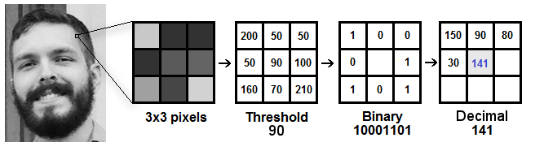

Based on the image above, let’s break it into several small steps so we can understand it easily:

* Suppose we have a facial image in grayscale.
* We can get part of this image as a window of 3x3 pixels.
* It can also be represented as a 3x3 matrix containing the intensity of each pixel (0~255).
* Then, we need to take the central value of the matrix to be used as the threshold.
* This value will be used to define the new values from the 8 neighbours.
* For each neighbor of the central value (threshold), we set a new binary value. We set 1 for values equal or higher than the threshold and 0 for values lower than the threshold.
* Now, the matrix will contain only binary values (ignoring the central value). We need to concatenate each binary value from each position from the matrix line by line into a new binary value (e.g. 10001101). Note: some authors use other approaches to concatenate the binary values (e.g. clockwise direction), but the final result will be the same.
* Then, we convert this binary value to a decimal value and set it to the central value of the matrix, which is actually a pixel from the original image.
* At the end of this procedure (LBP procedure), we have a new image which represents better the characteristics of the original image.
* **Note**: The LBP procedure was expanded to use a different number of radius and neighbours, it is called Circular LBP.

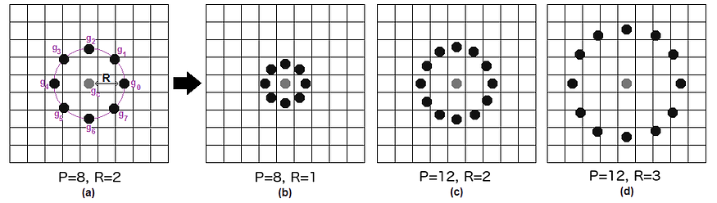

**Fig. 3.4** Circular LBP

It can be done by using **bilinear interpolation**. If some data point is between the pixels, it uses the values from the 4 nearest pixels (2x2) to estimate the value of the new data point.

**3. Extracting the Histograms**: Now, using the image generated in the last step, we can use the **Grid X** and **Grid Y** parameters to divide the image into multiple grids, as can be seen in the following image:

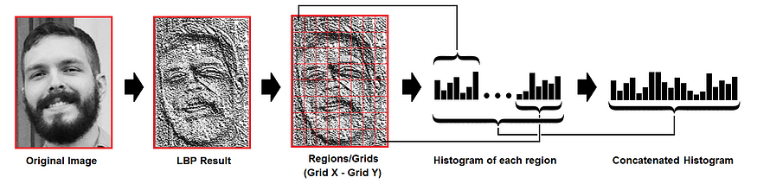

**Fig. 3.5** Extracting the Histograms

Based on the image above, we can extract the histogram of each region as follows:

* As we have an image in grayscale, each histogram (from each grid) will contain only 256 positions (0~255) representing the occurrences of each pixel intensity.
* Then, we need to concatenate each histogram to create a new and bigger histogram. Supposing we have 8x8 grids, we will have 8x8x256=16.384 positions in the final histogram. The final histogram represents the characteristics of the image original image.

The LBPH algorithm is pretty much it.

**4. Performing the face recognition**: In this step, the algorithm is already trained. Each histogram created is used to represent each image from the training dataset. So, given an input image, we perform the steps again for this new image and creates a histogram which represents the image.

* So to find the image that matches the input image we just need to compare two histograms and return the image with the closest histogram.
* We can use various approaches to compare the histograms (calculate the distance between two histograms), for example: **euclidean distance**, **chi-square**, **absolute value**, etc. In this example, we can use the Euclidean distance (which is quite known) based on the following formula:

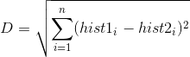

* So the algorithm output is the ID from the image with the closest histogram. The algorithm should also return the calculated distance, which can be used as a ‘**confidence**’ measurement. **Note**: don’t be fooled about the ‘confidence’ name, as lower confidences are better because it means the distance between the two histograms is closer.
* We can then use a threshold and the ‘confidence’ to automatically estimate if the algorithm has correctly recognized the image. We can assume that the algorithm has successfully recognized if the confidence is lower than the threshold defined.

# Chapter 4

# Methodology and Design

## Methodology

Before the attendance management system can work, there is a set of data needed to be inputted into the system which essentially consists of the individual’s basic information which is their ID and their faces. The first procedure of portrait acquisition can be done by using the Camera to capture the faces of the individual. In this process the system will first detect the presence of a face in the captured image, if there is no face detected, the system will prompt the user to capture their face again until it meets a certain number of portraits which will be 10 required portraits in this project for each student. The decision of storing only 10 portraits per student is due to the consideration of the limited storage space in the raspberry pi because the total amount of students in the university is considered heavy. Then, the images will undergo several pre-processing procedures to obtain a grayscale image and cropped faces of equal-sized images because those are the prerequisites of using the EigenFaces Recognizer. Both of the processes mentioned above can be represented in the diagram below



**Fig. 4.1** Method of Image Taking

## 4.2 Image Acquisition and Pre-processing procedures

## After the images are processed, they are stored in a file hierarchically. In this project, all the faces will be stored in a hierarchy manner under the „database‟ folder. When expanding through the database folder, there will consist of many sub-folders each of which will represent an individual where a series of face portraits belonging to the same individual will be stored in that particular sub-folder. The sub-folders that represent each individual will be named upon the ID no. of that individual which is unique for every single individual in the institution. The whole process of image retrieval, pre-processing, and storing mechanism is done by the script named facial_recognition.py



**Fig. 4.2** Image Acquisition

## Flow Chart of The Image Acquisition Process

The development of the face database is an important phase before any facial recognizing process can be carried out. It acts as a library to compare against whenever the system wanted to identify a person. In the image retrieval process, the system will first prompt for an input from the user to enter their ID number. The system will then validate the entered input and then check for duplication in the system. To proceed, the entered input must contain only 12 digits of the number. Apart from that, the ID inputted has to be a non-registered ID to ensure no duplication. After that, a directory is created for each individual where their portraits will be stored. It is compulsory to store 10 - 30 portraits per person in the file. After the acquisition of the image is done, the images undergo pre-processing before storing it into the respective folder.



**Fig. 4.3** Flow Chart of Image Acquisition Process

## 4.4 Project Workflow

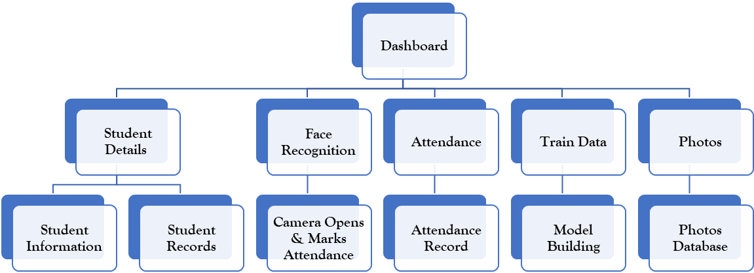

**Authenticated?**

**No**

**Fig. 4.4** Project Workflow

## 4.5 Result

# 

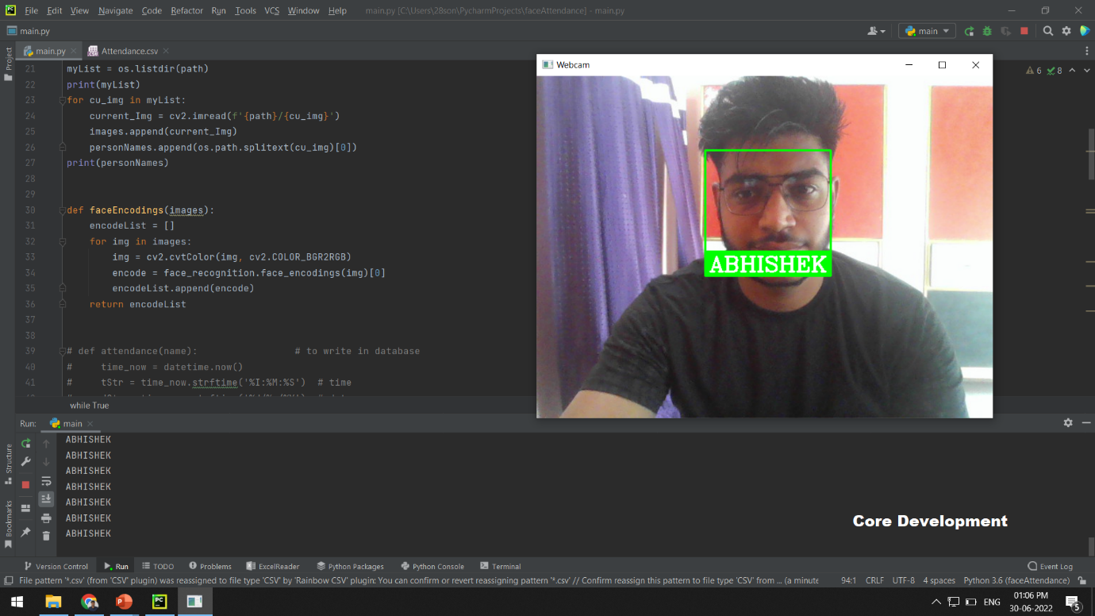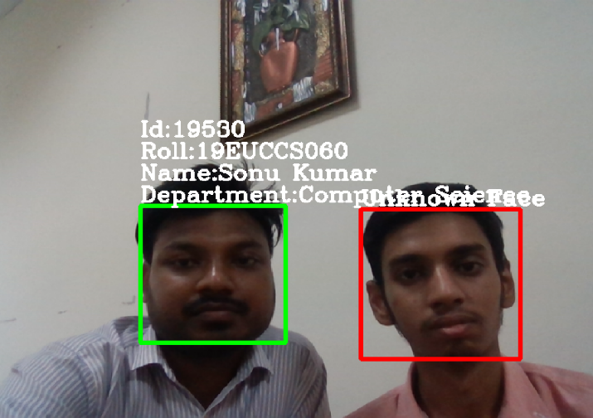

**Fig. 4.5** Image Taking by System

# 

**Fig. 4.6** Database Creation

# 

**Fig. 4.7** Student Attendance

# Conclusion

Before the development of this project. There are many loopholes in the process of taking attendance using the old method which caused many troubles for most of the institutions. Therefore, the facial recognition feature embedded in the attendance monitoring system can not only ensure attendance is taken accurately and also eliminated the flaws in the previous system. Using technology to conquer the defects cannot merely save resources but also reduces human intervention in the whole process by handling all the complicated tasks to the machine. The only cost to this solution is to have sufficient space in to store all the faces into the database storage. Fortunately, there is such an existence of micro-SD that can compensate with the volume of the data. In this project, the face database is successfully built. Apart from that, the face recognizing system is also working welkin The proposed facial recognition-based auto attendance system is many times more efficient than its fingerprint or RFID-based counterparts as no manual intervention is required. Saves time as the system works for several people simultaneously. The program is relatively lightweight and can be run on inexpensive hardware. A web-based Attendance System utilizing ML algorithms is planned with the rationale of lessening the mix-ups that might happen during conventional participation frameworks. Face acknowledgment is one of the simplest and most agreeable strategies to integrate into the participation framework. Contrasted and Eigenfaces and Fisher's algorithms, the LBPH algorithm has the most noteworthy acknowledgment exactness in all examinations with fluctuation in lights and clamors at each conceivable reach. LBPH likewise has the most noteworthy impression of the negative light openness and high commotion level analyzed to different algorithms with a factual methodology. Due to the most elevated precision got, the LBPH algorithm is utilized as a face acknowledgment algorithm in this framework.

# References

[1] Ekta Chhatar, Heeral Chauhan, Shubham Gokhale, Sompurna Mukherjee, Prof. Nikhil Jha, “Survey on Student Attendance Management System”, S.B. Jain Institute of Technology, Management and Research, Nagpur, 2016 pp. 1440-1448.

[2] Jun Lio, “Attendance Management System using a Mobile Device and a Web Application”, Department of Socio-informatics, Faculty of Letters Chuo University 742-1 Higashinakano, Hachioji-shi, Tokyo 192-0393, Japan, 2016 Volume: 23 , Issue: 3, pp. 1105- 1117

[3] Karwan Jacksi, Falah Ibrahim, Shahab Ali, “Student Attendance Management System”, University of Zakho, Iraq, 2018 pp 99- 112

[4] Jalendu Dhamija “An Advancement towards Efficient Face Recognition Using Live Video Feed” pp. 140-188.

[5] Shireesha Chintalapati and M.V. Raghunadh “Automated attendance management system based on face recognition algorithms” , Volume 5, Issue 12, pp 190-193.

[6] Suman Kumar Jha Aditya Tyagi, Kundan Kumar, and Madhvi Sharma “Attendance management system using face recognition” , Volume 2 Issue 10.

[7] Dulyawit Prangchumpol “Face Recognition for Attendance Management System Using Multiple System” pp. 40-1488.